What is the electron geometry and molecular geometry of each of the molecules?
Are there polar bonds? Is the molecule polar?

 | EG :  MG:  Polar Bonds?  Polar molecule? |  | EG :  MG:  Polar Bonds?  Polar molecule?
 | EG :  MG:  Polar Bonds?  Polar molecule? |  | EG :  MG:  Polar Bonds?  Polar molecule?
 | EG :  MG:  Polar Bonds?  Polar molecule? |  | EG :  MG:  Polar Bonds?  Polar molecule?
 | EG :  MG:  Polar Bonds?  Polar molecule? |  | EG :  MG:  Polar Bonds?  Polar molecule?
 | EG :  MG:  Polar Bonds?  Polar molecule? |  | EG :  MG:  Polar Bonds?  Polar molecule?
 | EG :  MG:  Polar Bonds?  Polar molecule? |  | EG :  MG:  Polar Bonds?  Polar molecule?
 | EG :  MG:  Polar Bonds?  Polar molecule? |  | EG :  MG:  Polar Bonds?  Polar molecule?

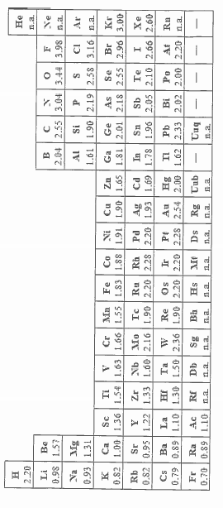
 | EG : trigonal planar  MG: trigonal planar  Polar Bonds? yes  Polar molecule? no |  | EG : tetrahedral  MG: bent  Polar Bonds? no  Polar molecule? no
 | EG : linear  MG: linear  Polar Bonds? yes  Polar molecule? no |  | EG : trigonal planar  MG: bent  Polar Bonds? yes  Polar molecule? yes
 | EG : tetrahedral  MG: tetrahedral  Polar Bonds? Yes (C-Cl)  Polar molecule? yes |  | EG : each C trigonal planar  MG: each C trigonal planar  Polar Bonds? Yes (C-F)  Polar molecule? no
 | EG : tetrahedral  MG: trigonal pyramidal  Polar Bonds? yes  Polar molecule? yes |  | EG : tetrahedral  MG: tetrahedral  Polar Bonds? no  Polar molecule? no
 | EG : trigonal planar  MG: bent  Polar Bonds? no  Polar molecule? no |  | EG : trigonal planar  MG: trigonal planar  Polar Bonds? Yes (C-O)  Polar molecule? yes
 | EG : tetrahedarl  MG: trigonal pyramidal  Polar Bonds? yes  Polar molecule? yes |  | EG : each C trigonal planar  MG: each C trigonal planar  Polar Bonds? Yes (C-Cl)  Polar molecule? yes
 | EG : trigonal planar  MG: trigonal planar  Polar Bonds? yes  Polar molecule? no |  | EG : each carbon linear  MG: each carbon linear  Polar Bonds? Yes (C-F)  Polar molecule? no

